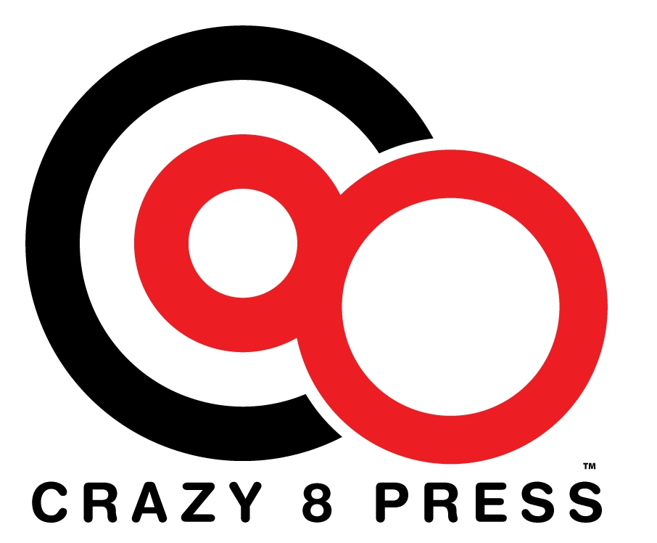
We need your help

To better make people aware of our offerings we need to understand where you learn of new releases, where you read reviews, and where you make your purchases. Please fill this out and return it to Crazy 8 Press at our table or should you see one of the authors. Many thanks for your help.

Please mark your answers with an X.

Do you read eBooks? If so, what platform do you use?
- Kindle (device, app, desktop program)
- Nook (device, app, desktop program)
- Kobo
- iBooks
- DRM-free epub/pdf
- Other _____________

Where did you hear about the ebook you most recently read/are reading?
(If this is different from where you usually hear about ebooks, mark that with a “U”.)
- Friend’s recommendation
- Online review
- Online ad
- Author’s blog
- Kindle spotlight
- Goodreads recommendation
- Amazon recommendation
- Other _____________

Where did you buy the ebook you most recently read/are reading?
(If this is different from where you usually buy ebooks, mark that with a “U”.)
- Directly through app/reader from Amazon
- Directly through app/reader from Barnes & Noble
- Other online store
- Direct from the publisher (including Lulu, Smashwords, etc.)
- Borrow from the library
- Free download from Project Gutenberg or similar site
- Filesharing download
- Other _____________

